<Facility Module> by < >

4.1.1 Brief Description

There are 4 main function in this module which is Add New Facility function, Search Facility function, Display Facility function and Modify Facility function.

Add New Facility Function

User can enter facility type, facility ID, facility description, facility allowed user amount, and facility venue. After entering these information, the system will confirm new facility details. After that, system will ask user confirm want to add this new facility or not. Then system ask user what to do next. By entering ‘1’, system will proceed to add another new facility and ‘2’ to return to previous page.

Search Facility Function

User can enter the searched facility Type or ID. The system will display the facility details record founded in the system which is facility ID, facility type, venue, facility allowed user, and facility description that the user searched. The system record founded in the system. The user can press ‘y’ to search another facility or ‘n’ to back to menu.

Display Facility Function

The system will display the information that already recorded in the system. Then, the facility ID, facility type, venue, facility allowed user, and the facility description will be displayed on the screen. The user can press ‘1’ to back to facility menu.

Modify Booking Function

The system will ask user whether want to modify facility ID, facility type, facility description, facility allowed user, or venue. After user select their choice, user will require to enter the new facility ID, facility type, facility description, facility allowed user, or venue of the facility they want to edit. Then system will ask user whether confirm to change it or not. After that, system ask user want to modify another facility or not. By entering ‘y’, user can modify another facility and ‘n’ to go back to menu.

4.1.2

a)

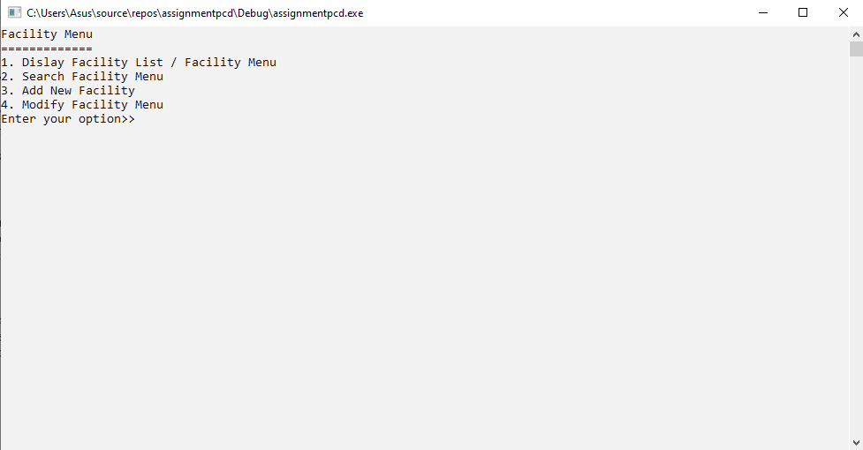

1) Main menu that display 4 function which is add facility function, search facility function, display facility function, and modify facility function.

b)  
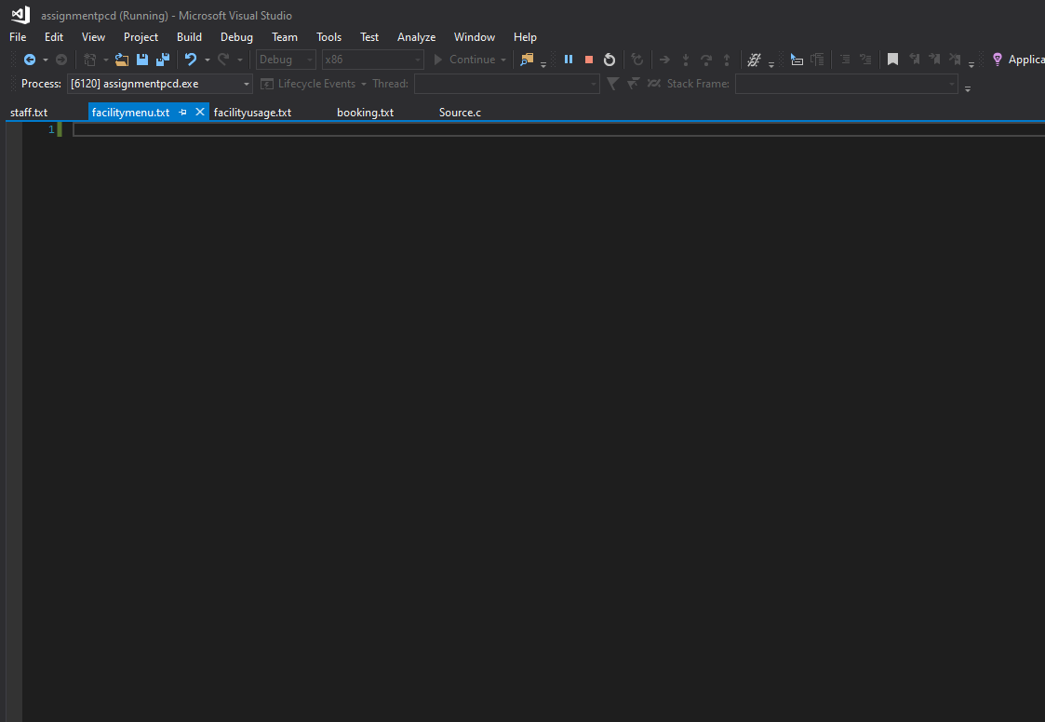

c)

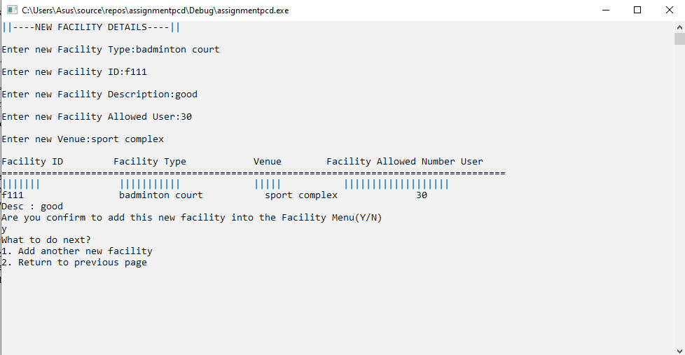

1)Enter the facility type,facility ID,facility description,facility allowed user,and venue.

2)The system will display all details and confirm one time with user.

3)The new facility is added.

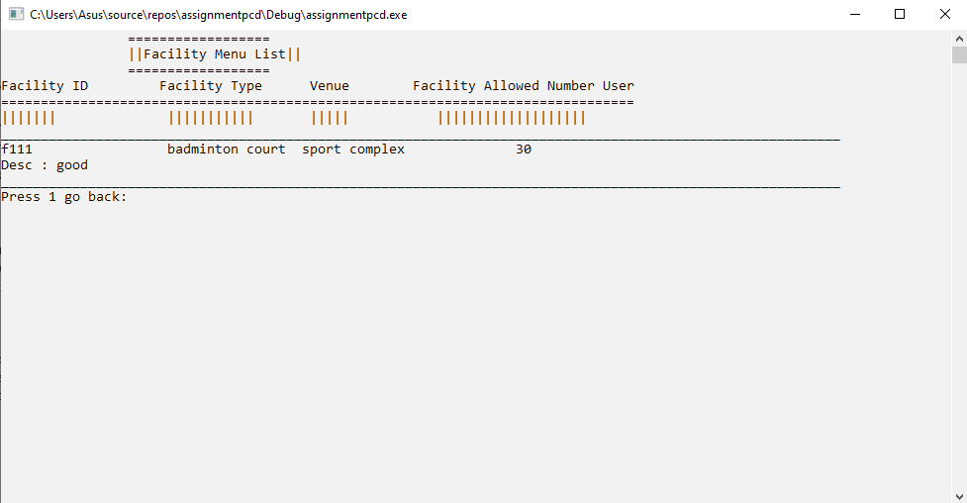

d) 

1)This is display facility function.

2) User can back to menu by enter ‘1’.

e)

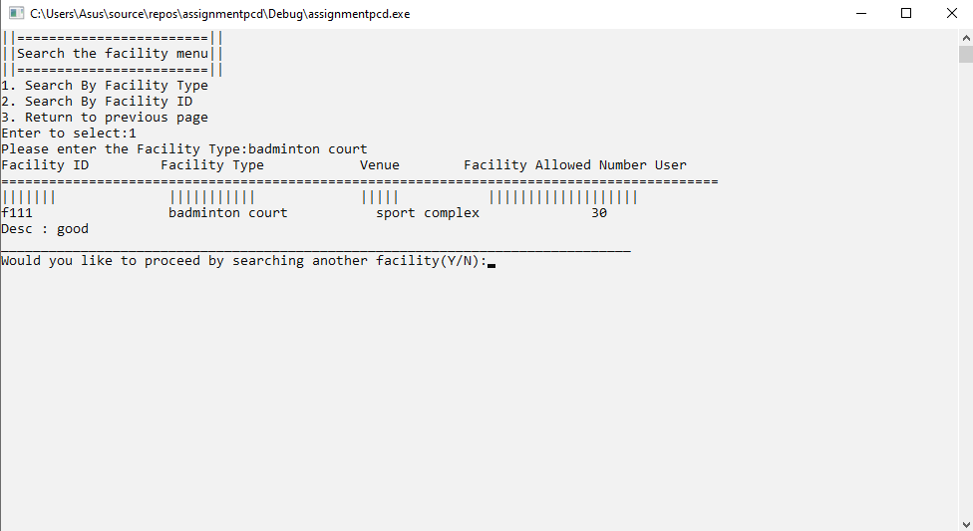

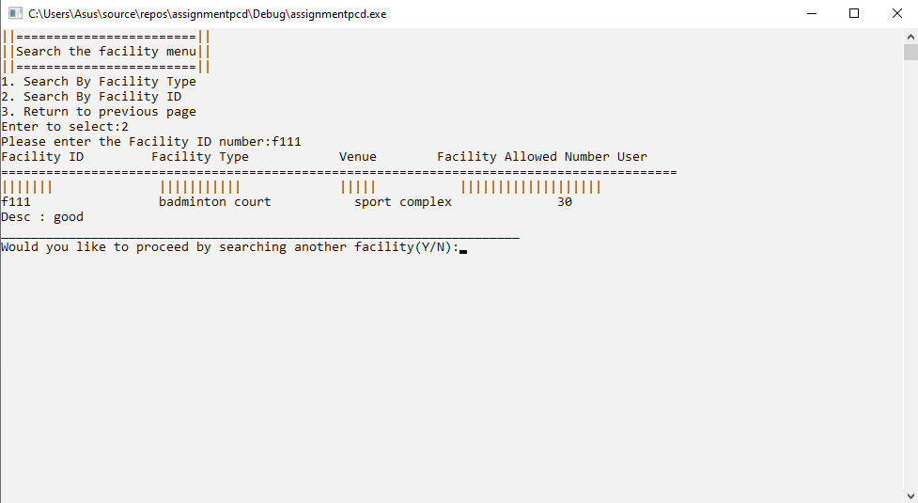

1)This is search facility function.

2)User can search facility by facility type or facility ID.

3)If facility type or ID found, system will display facility details.

f)

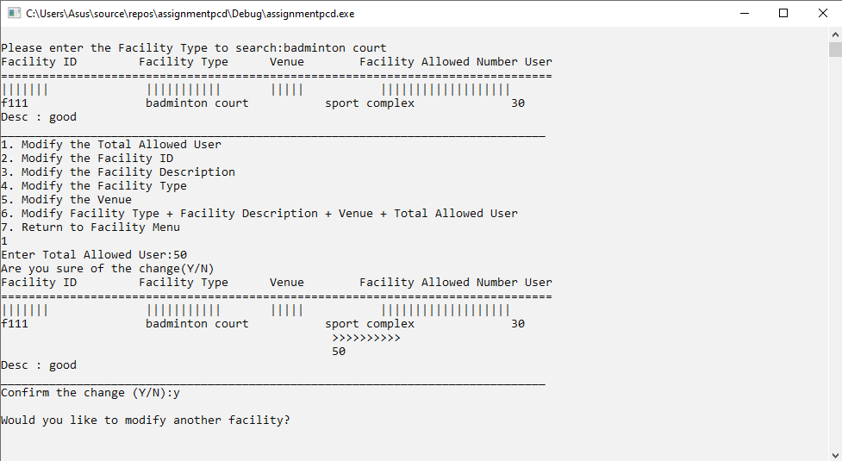

1) This is modify facility total allowed user function.

2)User can enter the new facility total allowed user.

3)The system will confirm one time with user.

4)The modify was successfully proceed.

5)Enter ‘y’ to modify another facility or ‘n’ to back to menu.

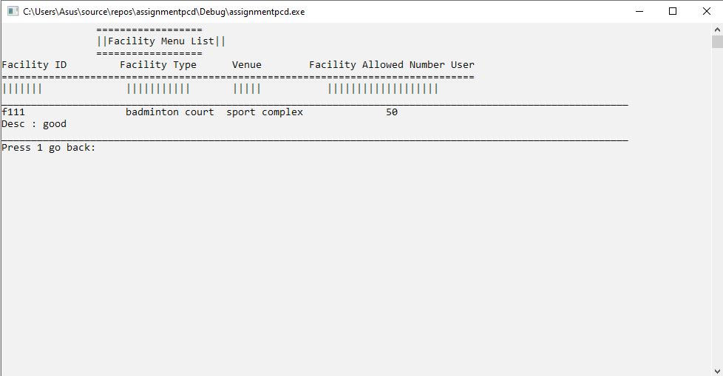

g)

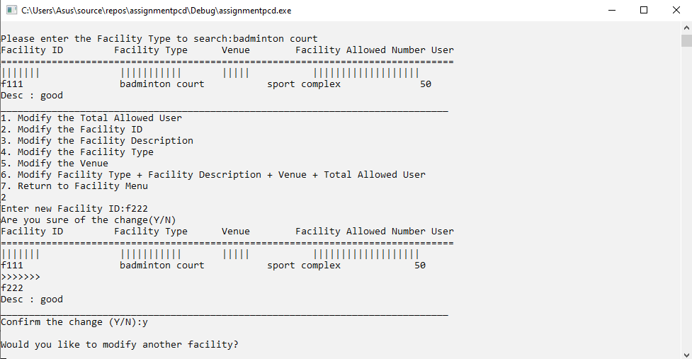

1) This is modify facility ID function.

2)User can enter the new facility ID.

3)The system will confirm one time with user.

4)The modify was successfully proceed.

5)Enter ‘y’ to modify another facility or ‘n’ to back to menu.

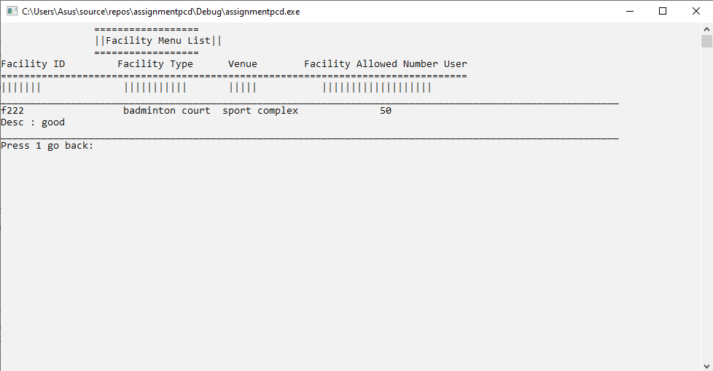

h)

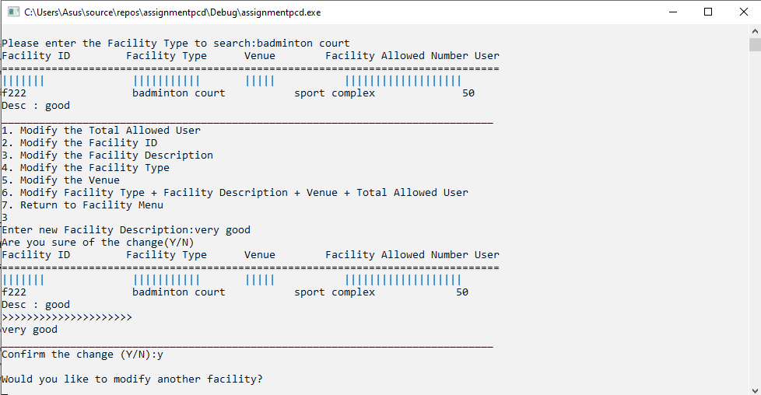

1) This is modify facility description function.

2)User can enter the new facility description.

3)The system will confirm one time with user.

4)The modify was successfully proceed.

5)Enter ‘y’ to modify another facility or ‘n’ to back to menu.

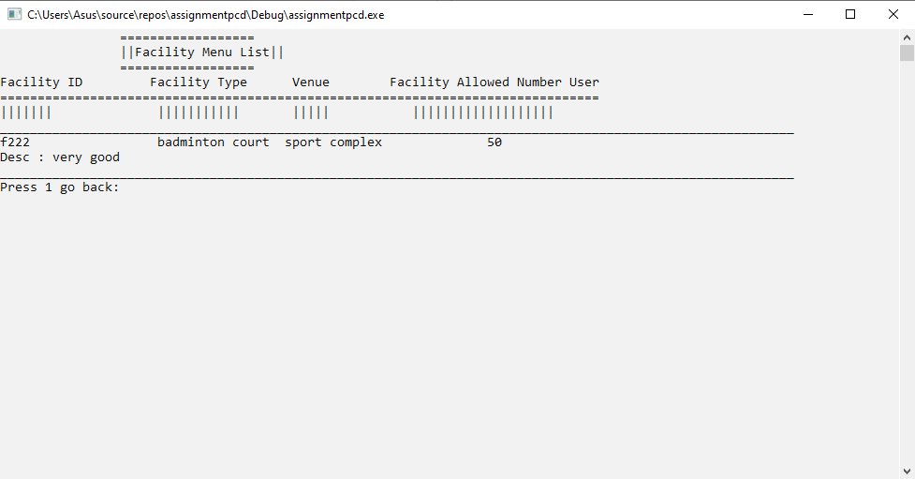

i)

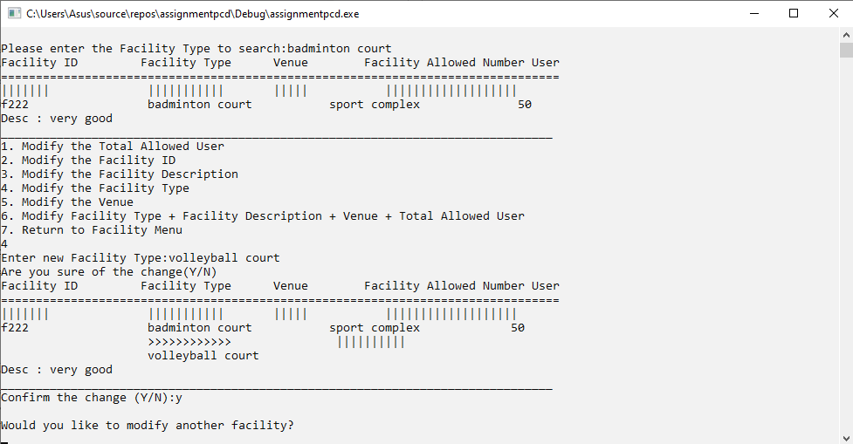

1) This is modify facility type function.

2)User can enter the new facility type.

3)The system will confirm one time with user.

4)The modify was successfully proceed.

5)Enter ‘y’ to modify another facility or ‘n’ to back to menu.

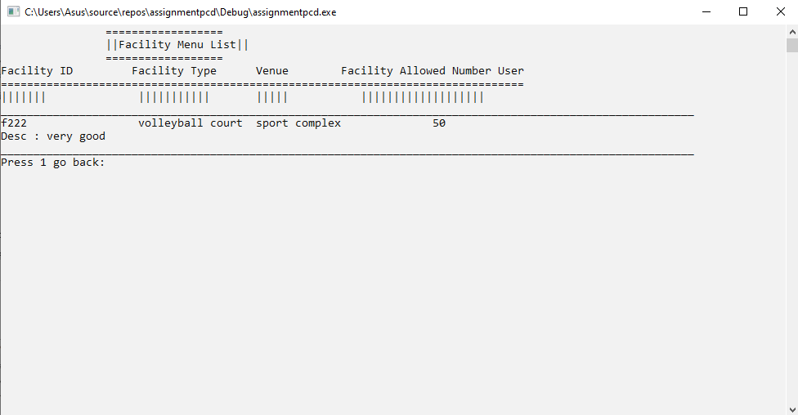

j)

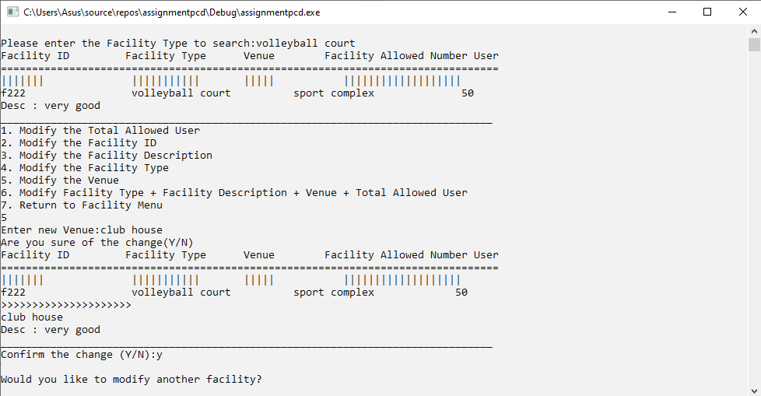

1) This is modify facility venue function.

2)User can enter the new facility venue.

3)The system will confirm one time with user.

4)The modify was successfully proceed.

5)Enter ‘y’ to modify another facility or ‘n’ to back to menu.

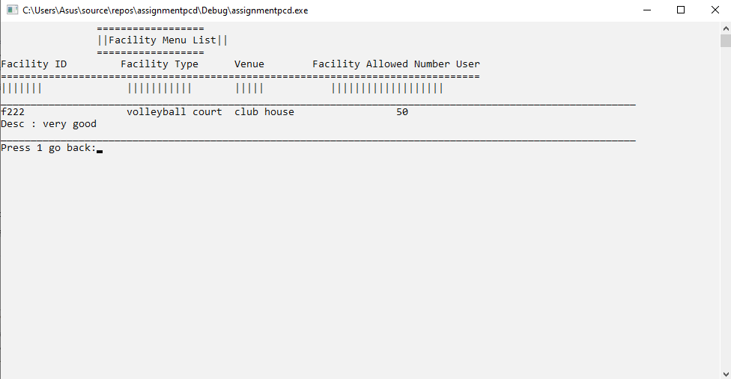

k)

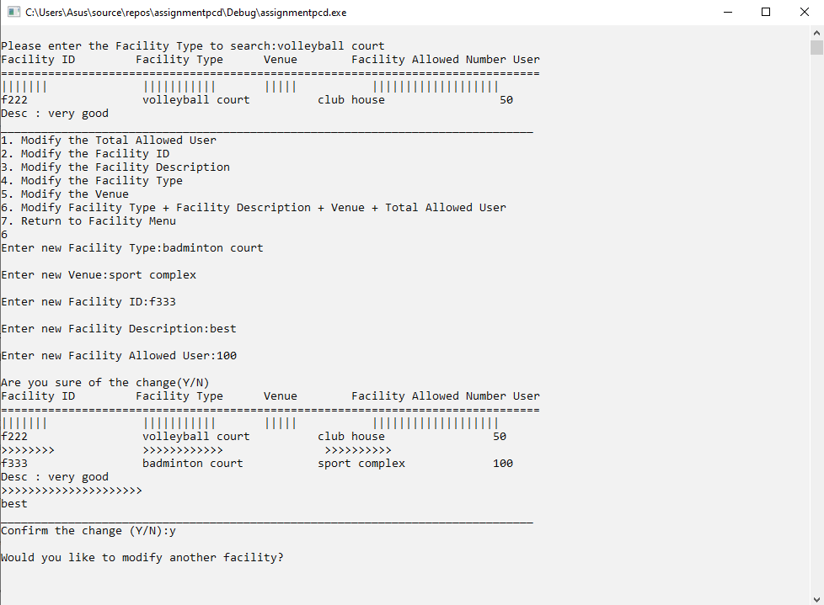

1) This is modify facility total allowed user, facility description, facility type, and facility venue function.

2)User can enter the new total allowed user, facility description, facility type, and facility venue.

3)The system will confirm one time with user.

4)The modify was successfully proceed.

5)Enter ‘y’ to modify another facility or ‘n’ to back to menu.

